**What is mean by Neural Networks?**

A **neural network** is a series of algorithms that endeavors to recognize underlying relationships in a set of data through a process that mimics the way the human brain operates. In this sense, **neural networks** refer to systems of neurons, either organic or artificial in nature.

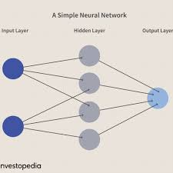

The Artificial Neural Network is the Functional Unit of Deep Learning.

Artificial Neural Networks that behave similar to the Neural Networks in our brain.

It works when some input data is fed to it. This data is then processed via layers of **Perceptrons** to produce the desired output.

Motivation behind neural networks is the **Biological Neuron.**

**Real Time Applications:**

**Google Translate:** It can instantly translate more than 100 different human languages.

**Tesla: Self Driving Cars** are being perfected with the help of neural networks

Siri

Alexa

Cortana

**Open AI:** AI bots just beat humans at the video game DOTA 2. That’s a big deal, because their victory required teamwork and collaboration – a huge milestone in advancing Artificial Intelligence. (-- Bill Gates)

**MuseNet:** A Deep Neural Network that can Generate 4-minute musical compositions with 10 different instruments.

**Wordsmith:** It is Natural Language Processing Platform. It is a AI-powered tool that produces written analytics by transforming the given data.

**You tube:** [**https://www.youtube.com/watch?v=vpOLiDyhNUA&ab_channel=edureka%21**](https://www.youtube.com/watch?v=vpOLiDyhNUA&ab_channel=edureka%21)

**What is mean by Deep Learning?**

It is an artificial Intelligence (AI) function that imitates the workings of the human brain in processing the data and creating patterns for use in decision making. Also known as **deep** neural **learning** or **deep neural network.**

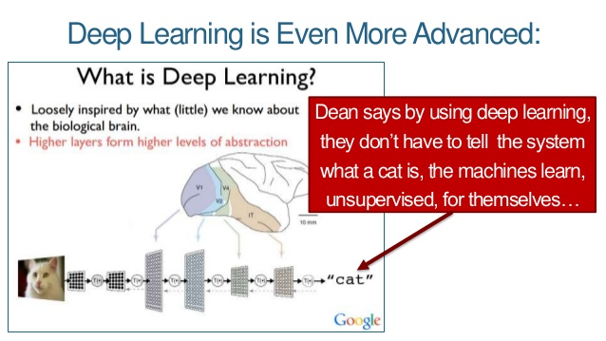

It is used to build learning Algorithms that mimic brain.

Deep Learning Models are capable to focus on the right features by themselves, requiring little guidance from the programmer.

These deep learning models also partially solve the dimensionality problem.

A Collection of statistical machine learning techniques used to learn feature hierarchies often based on artificial neural networks.

**Deep Networks:**

Neural Networks with multiple Hidden Layers.

**Applications of Deep Learning:**

1. Self-Driving Cars
2. Automatic Image Caption Generation
3. Voice Controlled Assistance
4. Automatic Machine Translation

**You tube:** [**https://www.youtube.com/watch?v=dafuAz_CV7Q&ab_channel=edureka%21**](https://www.youtube.com/watch?v=dafuAz_CV7Q&ab_channel=edureka%21)